
у

Solomiya Andrusiv
Lab - Exploring Nmap

Topology
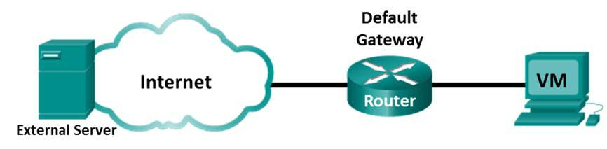

Objectives

Part 1: Exploring Nmap

Part 2: Scanning for Open Ports

Background / Scenario

Port scanning is usually part of a reconnaissance attack. There are a variety of port scanning methods that can be used. We will explore how to use the Nmap utility. Nmap is a powerful network utility that is used for network discovery and security auditing.

Required Resources

CyberOps Workstation Virtual Machine Internet access

Part 1: Exploring Nmap

In this part, you will use manual pages (or man pages for short) to learn more about Nmap.

The man [ program |utility | function] command displays the manual pages associated with the arguments. The manual pages are the reference manuals found on Unix and Linux OSs. These pages can include these sections: Name, Synopsis, Descriptions, Examples, and See Also.

- Start CyberOps Workstation VM.

- Open a terminal.

Cisco and/or its affiliates. All rights reserved. Cisco Confidential Page 1 of 7 www.netacad.com
Lab - Exploring Nmap

- At the terminal prompt, enter man nmap.

[analyst@secOps ~]$ man nmap
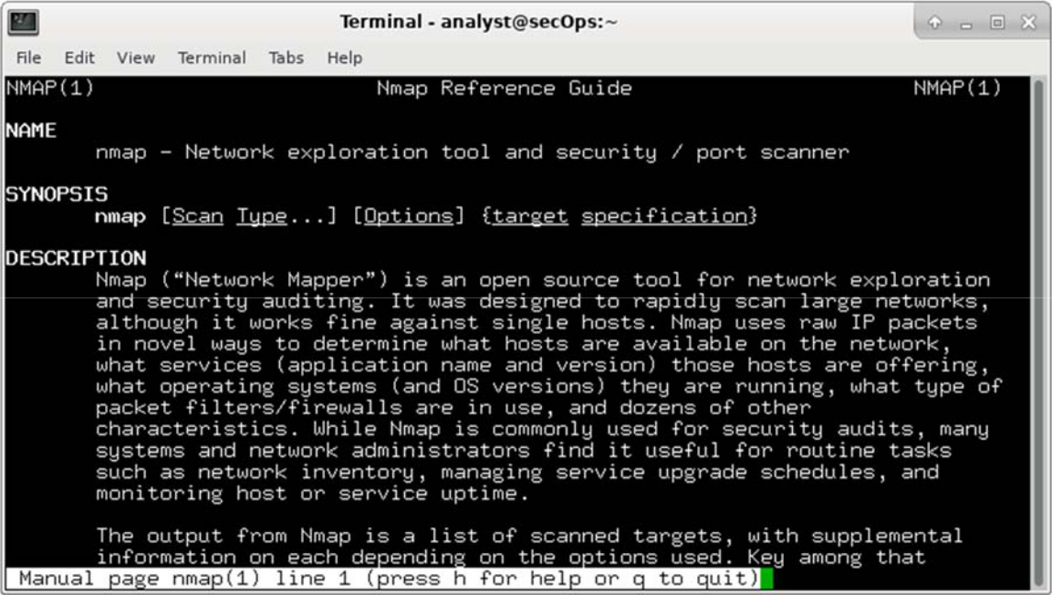

What is Nmap?

пз з відкритим кодом, призначене для дослідження мереж та аудиту їх безпеки

What is nmap used for?

Використовується для того щоб сканувати великі мережі. використовує необроблені ір пакети щоб визначити які хости доступні в мережі, які послуги пропонують ці хости, їх ОС та десятки інших характеристик

- While in the man page, you can use the up and down arrow keys to scroll through the pages. You can also press the space bar to forward one page at a time.

To search for a specific term or phrase use enter a forward slash (/) or question mark (?) followed by the term or phrase. The forward slash searches forward through the document, and the question mark searches backward through the document. The key n moves to the next match.

Cisco and/or its affiliates. All rights reserved. Cisco Confidential Page 2 of 7 www.netacad.com

Lab - Exploring Nmap

Type /example and press ENTER. This will search for the word example forward through the man page.
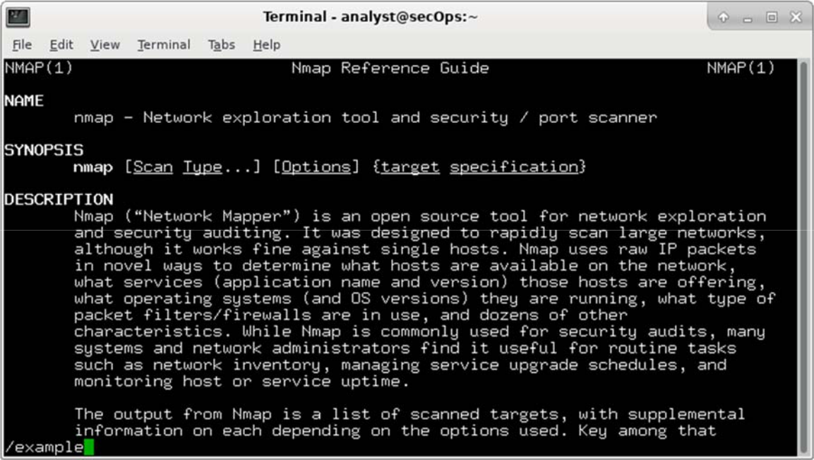

e. In the first instance of example, you see three matches. To move to the next match, press n.
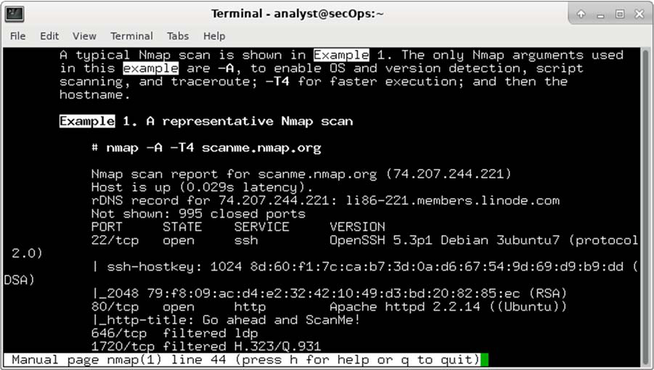

Look at Example 1. What is the nmap command used?

give scan report for scanme.nmap.org

Use the search function to answer the following questions.

What does the switch -A do?

enable OS and version detection, script scanning and traceroute

Cisco and/or its affiliates. All rights reserved. Cisco Confidential Page 3 of 7 www.netacad.com

Lab - Exploring Nmap

What does the switch -T4 do?

prohibits the dynamic scan delay from exceeding 10ms for TCP ports

- Scroll through the page to learn more about nmap. Type q when finished.

Part 2: Scanning for Open Ports

In this part, you will use the switches from the example in the Nmap man pages to scan your localhost, your local network, and a remote server at scanme.nmap.org.

Step 1: Scan your localhost.

- If necessary, open a terminal on the VM. At the prompt, enter nmap -A -T4 localhost. Depending on your local network and devices, the scan will take anywhere from a few seconds to a few minutes.

[analyst@secOps Desktop]$ nmap -A -T4 localhost

Starting Nmap 7.40 ( https://nmap.org ) at 2017-05-01 17:20 EDT Nmap scan report for localhost (127.0.0.1)

Host is up (0.000056s latency).

Other addresses for localhost (not scanned): ::1

rDNS record for 127.0.0.1: localhost.localdomain

Not shown: 996 closed ports
PORT | STATE | SERVICE | VERSION
21/tcp open |  | ftp | vsftpd 2.0.8 or later
| ftp-anon: Anonymous FTP login allowed (FTP code 230)
|_-rw-r--r-- |  | 1 0 | 0 | 0 Apr 19 15:23 ftp_test
22/tcp open |  | ssh | OpenSSH 7.4 (protocol 2.0)
| ssh-hostkey:
| | 2048 f1:61:50:02:94:ba:f2:bd:be:93:cf:14:58:36:b8:32 (RSA)
|_ | 256 94:33:25:a5:0e:02:d7:bc:c8:b0:90:8a:a2:16:59:e5 (ECDSA)
23/tcp open |  | telnet | Openwall GNU/*/Linux telnetd
80/tcp open |  | http | nginx 1.12.0
|_http-server-header: nginx/1.12.0
|_http-title: Welcome to nginx!

Service Info: Host: Welcome; OS: Linux; CPE: cpe:/o:linux:linux_kernel

Service detection performed. Please report any incorrect results at https://nmap.org/submit/ .

Nmap done: 1 IP address (1 host up) scanned in 18.81 seconds

- Review the results and answer the following questions. Which ports and services are opened?
21/tcp ftp
22/tcp ssh

For each of the open ports, record the software that is providing the services.

What is the operating system? OS:Linux

Cisco and/or its affiliates. All rights reserved. Cisco Confidential Page 4 of 7 www.netacad.com

Lab - Exploring Nmap

____________________________________________________________________________________

Step 2: Scan your network.

Warning: Before using Nmap on any network, please gain the permission of the network owners before proceeding.

- At the terminal command prompt, enter ifconfig to determine the IP address and subnet mask for this host. For this example, the IP address for this VM is 192.168.1.19 and the subnet mask is 255.255.255.0.

[analyst@secOps ~]$ ifconfig

enp0s3: flags=4163<UP,BROADCAST,RUNNING,MULTICAST> mtu 1500

inet 192.168.1.19 netmask 255.255.255.0 broadcast 192.168.1.255 inet6 fe80::997f:9b16:5aae:1868 prefixlen 64 scopeid 0x20<link> ether 08:00:27:c9:fa:a1 txqueuelen 1000 (Ethernet)

RX packets 34769 bytes 5025067 (4.7 MiB) RX errors 0 dropped 0 overruns 0 frame 0 TX packets 10291 bytes 843604 (823.8 KiB)
TX errors 0 dropped 0 overruns 0 carrier 0 collisions 0 device interrupt 19 base 0xd000

Record the IP address and subnet mask for your VM. Which network does your VM belong to?

10.0.2.15 255.255.255.0
broadcast 10.0.2.255

- To locate other hosts on this LAN, enter nmap -A -T4 network address/prefix. The last octet of the IP address should be replaced with a zero. For example, in the IP address 192.168.1.19, the .19 is the last octet. Therefore, the network address is 192.168.1.0. The /24 is called the prefix and is a shorthand for the netmask 255.255.255.0. If your VM has a different netmask, search the Internet for a “CIDR conversion table” to find your prefix. For example, 255.255.0.0 would be /16. The network address 192.168.1.0/24 is used in this example

Note: This operation can take some time, especially if you have many devices attached to the network. In one test environment, the scan took about 4 minutes.
[analyst@secOps ~]$ nmap -A -T4 192.168.1.0/24

Starting Nmap 7.40 ( https://nmap.org ) at 2017-05-01 17:13 EDT

Nmap scan report for 192.168.1.1

Host is up (0.0097s latency).

Not shown: 996 |  |  | closed ports
PORT |  | STATE | SERVICE | VERSION
21/tcp |  | open | ftp | Bftpd 1.6.6
53/tcp |  | open | domain | dnsmasq 2.15-OpenDNS-1
| dns-nsid:
| | id.server:
|_ | bind.version: dnsmasq-2.15-OpenDNS-1
80/tcp |  | open | tcpwrapped
| http-auth:
| HTTP/1.0 401 |  |  | Unauthorized\x0D
|_ | Basic realm=NETGEAR WNR3500Lv2
|_http-title: |  |  | 401 Unauthorized
5000/tcp |  | open | tcpwrapped
Service Info: |  |  | Host: 192.168.1.1

Cisco and/or its affiliates. All rights reserved. Cisco Confidential Page 5 of 7 www.netacad.com

Lab - Exploring Nmap

Nmap scan report for |  |  | 192.168.1.19
Host is up (0.00016s |  |  | latency).
Not shown: 996 closed ports
PORT | STATE | SERVICE | VERSION
21/tcp open |  | ftp | vsftpd 2.0.8 or later
| ftp-anon: Anonymous FTP login allowed (FTP code 230)
|_-rw-r--r-- |  | 1 0 | 0 | 0 Apr 19 15:23 ftp_test
22/tcp open |  | ssh | OpenSSH 7.4 (protocol 2.0)
| ssh-hostkey:
| | 2048 f1:61:50:02:94:ba:f2:bd:be:93:cf:14:58:36:b8:32 (RSA)
|_ | 256 94:33:25:a5:0e:02:d7:bc:c8:b0:90:8a:a2:16:59:e5 (ECDSA)
23/tcp open |  | telnet | Openwall GNU/*/Linux telnetd
80/tcp open |  | http | nginx 1.12.0
|_http-server-header: nginx/1.12.0
|_http-title: Welcome to nginx!
Service Info: Host: Welcome; OS: Linux; CPE: cpe:/o:linux:linux_kernel <some output omitted>

Service detection performed. Please report any incorrect results at https://nmap.org/submit/ .

Nmap done: 256 IP addresses (5 hosts up) scanned in 34.21 seconds
How many hosts are up?

1 host up

From your Nmap results, list the IP addresses of the hosts that are on the same LAN as your VM. List some of the services that are available on the detected hosts.

only one host, services ftp and ssh

Step 3: Scan a remote server.

- Open a web browser and navigate to scanme.nmap.org. Please read the message posted. What is the purpose of this site?

‘to help folks learn about nmap’ and teat and make sure that nmap installation is working properly

- At the terminal prompt, enter nmap -A -T4 scanme.nmap.org.

[analyst@secOps Desktop]$ nmap -A -T4 scanme.nmap.org

Starting Nmap 7.40 ( https://nmap.org ) at 2017-05-01 16:46 EDT Nmap scan report for scanme.nmap.org (45.33.32.156)

Host is up (0.040s latency).

Other addresses for scanme.nmap.org (not scanned): 2600:3c01::f03c:91ff:fe18:bb2f

Not shown: 992 |  | closed ports
PORT | STATE |  | SERVICE | VERSION
22/tcp | open |  | ssh | OpenSSH 6.6.1p1 Ubuntu 2ubuntu2.8 (Ubuntu Linux;
protocol | 2.0)
| ssh-hostkey:
| 1024 | ac:00:a0:1a:82:ff:cc:55:99:dc:67:2b:34:97:6b:75 (DSA)

Cisco and/or its affiliates. All rights reserved. Cisco Confidential Page 6 of 7 www.netacad.com

Lab - Exploring Nmap

| | 2048 20:3d:2d:44:62:2a:b0:5a:9d:b5:b3:05:14:c2:a6:b2 (RSA)
|_ | 256 | 96:02:bb:5e:57:54:1c:4e:45:2f:56:4c:4a:24:b2:57 (ECDSA)
25/tcp |  | filtered | smtp
80/tcp |  | open | http | Apache httpd 2.4.7 ((Ubuntu))
|_http-server-header: Apache/2.4.7 (Ubuntu)
|_http-title: Go ahead and ScanMe!
135/tcp |  | filtered | msrpc
139/tcp |  | filtered | netbios-ssn
445/tcp |  | filtered | microsoft-ds
9929/tcp |  | open | nping-echo | Nping echo
31337/tcp open |  |  | tcpwrapped
Service |  | Info: OS: Linux; CPE: cpe:/o:linux:linux_kernel
Service |  | detection performed. Please report any incorrect results at
https://nmap.org/submit/ .

Nmap done: 1 IP address (1 host up) scanned in 23.96 seconds

- Review the results and answer the following questions. Which ports and services are opened?
22/tcp ssh
80/tcp http
9929/tcp nping-echo
31337/tcp tcpwrapped

Which ports and services are filtered?

no one

What is the IP address of the server?

45.33.32.156

What is the operating system?

Linux
Reflection

Nmap is a powerful tool for network exploration and management. How can Nmap help with network security?

How can Nmap be used by a threat actor as a nefarious tool?

nmap це набір інструментів для сканування мережі. Він може бути використаний для перевірки безпеки, просто для визначення запущених сервісів, для ідентифікації ОС і додатків, визначення типу фаервола тощо.
Так як nmap open-sourse утиліта, за допомогою nmap будь-який хакер може дізнатися які порти відкриті в системі, які програми запущені на сервері, може знайти вразливості будь-якого сервера.

Cisco and/or its affiliates. All rights reserved. Cisco Confidential Page 7 of 7 www.netacad.com

